**Uploading recorded data to BHRIC (via Filelocker)**

Please note that multi-factor authentication (MFA) must be set up on your FAU account and the DUO Mobile App must be installed on your smartphone and set up to receive push notifications. Without this will not be possible to sign into BHRIC and access the CON virtual desktop. Please see the link below for additional information if needed:

[Two-Factor and Multi-Factor Authentication at Florida Atlantic University](https://www.fau.edu/oit/accounts/mfa.php)

Make sure that the recording device is connected to the physical computer that will be used to access your CON virtual desktop on the BHRIC. In this example the recording device can be seen below as **Tape-Record (E:)**.

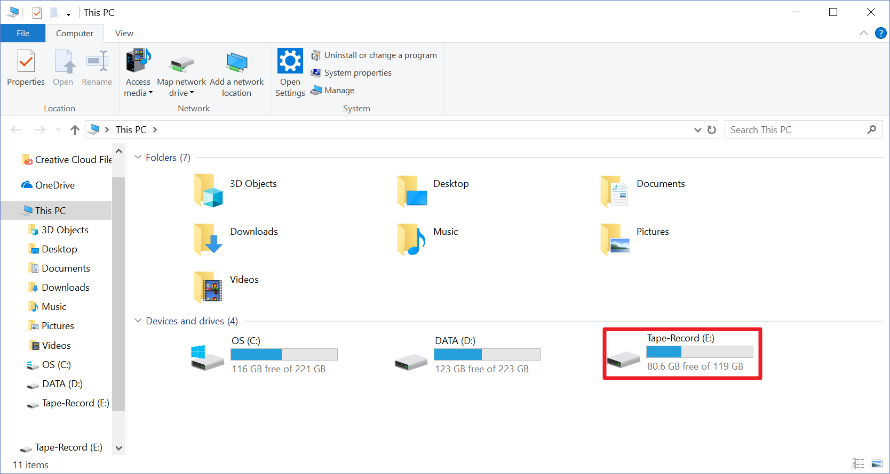

1. In the Google Chrome web browser, visit [filelocker.fau.edu](../../filelocker.fau.edu) and log in by providing your FAUNet ID+Password, then complete the MFA login by approving the push notification sent to the smartphone through DUO MFA.
2. Once you have signed in and are able to view the Filelocker page, click **Upload** and navigate to the file to be uploaded. Once the file is uploaded it will be scanned and encrypted.

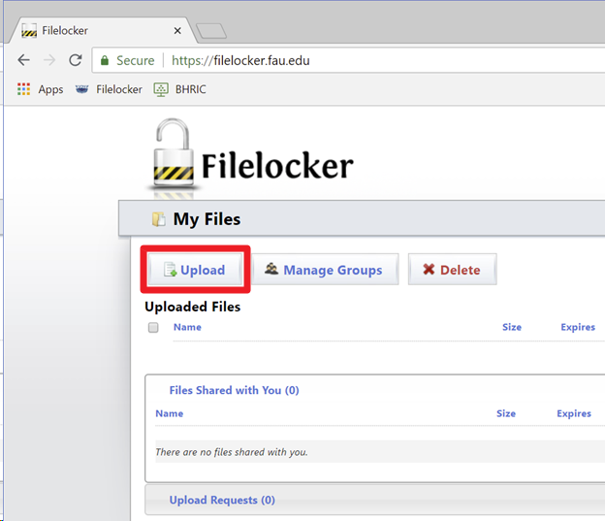

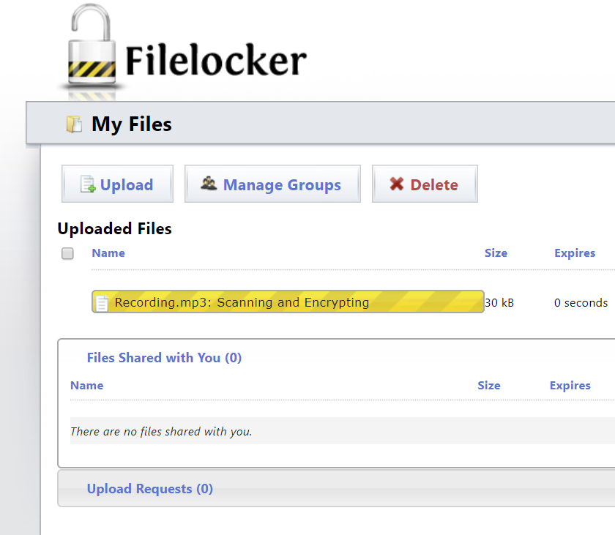

1. After uploading the file or files to Filelocker, follow the instructions provided in **step 3 a** if using an FAU-issued laptop or desktop or **step 3 b** if not using an FAU issued laptop or desktop.
   1. If using an FAU issued laptop or desktop, look for the VMware Horizon shortcut on your desktop and launch the application. Alternatively, the VMware Horizon application can be launched from the Start menu under the Program group letter **V**.

Note: If you do not have VMware Horizon installed on your FAU issued desktop or laptop you may request an installation of VMware Horizon on your FAU issued desktop/laptop by emailing Jony Singh ([jsingh@health.fau.edu](mailto:jsingh@health.fau.edu))

When the application launches a login prompt will appear. Log in using your FAUNet ID+Password in the following format (see screenshot below for example):

Username: **fau\<your FAUNet ID>**

Password: **<your Password>**

|  |  |
| --- | --- |
|  | After clicking the **Login** button a push notification will be sent to the smartphone through DUO MFA. Approve the notification request to complete the login. |

* 1. If not using an FAU issued laptop or desktop, visit [vhealth.fau.edu](../../vhealth.fau.edu) and log in using your FAUNet ID+Password in the following format (see screenshot below for example):

Username: **fau\<your FAUNet ID>**

|  |  |
| --- | --- |
|  | After clicking the **Login** button a push notification will be sent to the smartphone through DUO MFA. Approve the notification request to complete the login. |

Password: **<your Password>**

1. Click on the CON_NONPER desktop to access the BHRIC virtual desktop. Once you are in the CON_NONPER desktop, open the Google Chrome web browser. In the Google Chrome web browser, visit [filelocker.fau.edu](../../filelocker.fau.edu) and log in by providing your FAUNet ID+Password, then complete the MFA login by approving the push notification sent to the smartphone through DUO MFA.
2. Click on the file that you’ve transferred to Filelocker in **Step 2** to expand the file options, then click **Download This File** to save the file to your CON_NONPER virtual desktop. By default, Google Chrome will store downloaded files in the **Downloads** folder.

